Image carousel(carousel_slider)

Exercise #2

Flutter Developer Bootcamp

# **Purpose**

This exercise demonstrates how to implement an image carousel in a Flutter application using the carousel_slider package.

**Problem**

In the provided Exercise You need to create as follows:

In the given exercise demonstrates creating an image carousel using the carousel_slider package. The main entry point runs the MyApp widget, which is a stateless widget returning a MaterialApp that houses the ImageCarousel widget.ImageCarousel, also stateless, contains a list of image URLs (imgList) and builds a Scaffold with an AppBar titled "Image Carousel". The body centers a CarouselSlider widget configured for automatic sliding, responsive aspect ratio, and enlarging the center image. The CarouselSlider maps each URL in imgList to a Container with an Image.network that displays the image with BoxFit.cover.

**How to Solve**

1. Checkout the exercise from Git Repo:

git clone -b <user-branch> <repo-URL>

2. Open the root folder inside VS Code

3. To build the app click the run option in the main method{}

4. Import Required Packages

* import 'package:flutter/material.dart';
* import 'package:carousel_slider/carousel_slider.dart';

5. Demonstrates creating an image carousel in Flutter.

6. Shows image loading from the network.

7. Implements responsive design with aspectRatio and BoxFit.cover.

9. Go To File: <specific-file-with--method> à <method-name>, implement your logic.

**You will Achieve**

When you complete this Exercise you will learn the following:

**Imports:**

* **package:**flutter/material.dart: Provides Flutter’s core components and material design elements.
* **package:**carousel_slider/carousel_slider.dart: Provides the CarouselSlider widget for creating carousels.

**Widgets:**

* **MaterialApp:** Wraps the entire app, providing material design elements.
* **Scaffold:** Provides a layout structure with an AppBar and body.
* **AppBar:** Displays the app bar with the title "Image Carousel".
* **Center:** Centers its child widget within itself.
* **CarouselSlider:** Creates the image carousel with various configuration options.
* **Container:** Contains each image within the carousel.
* **Image.network:** Loads and displays images from the provided URLs.

# **Screenshots**

## **Expected output(carousel-slider)**

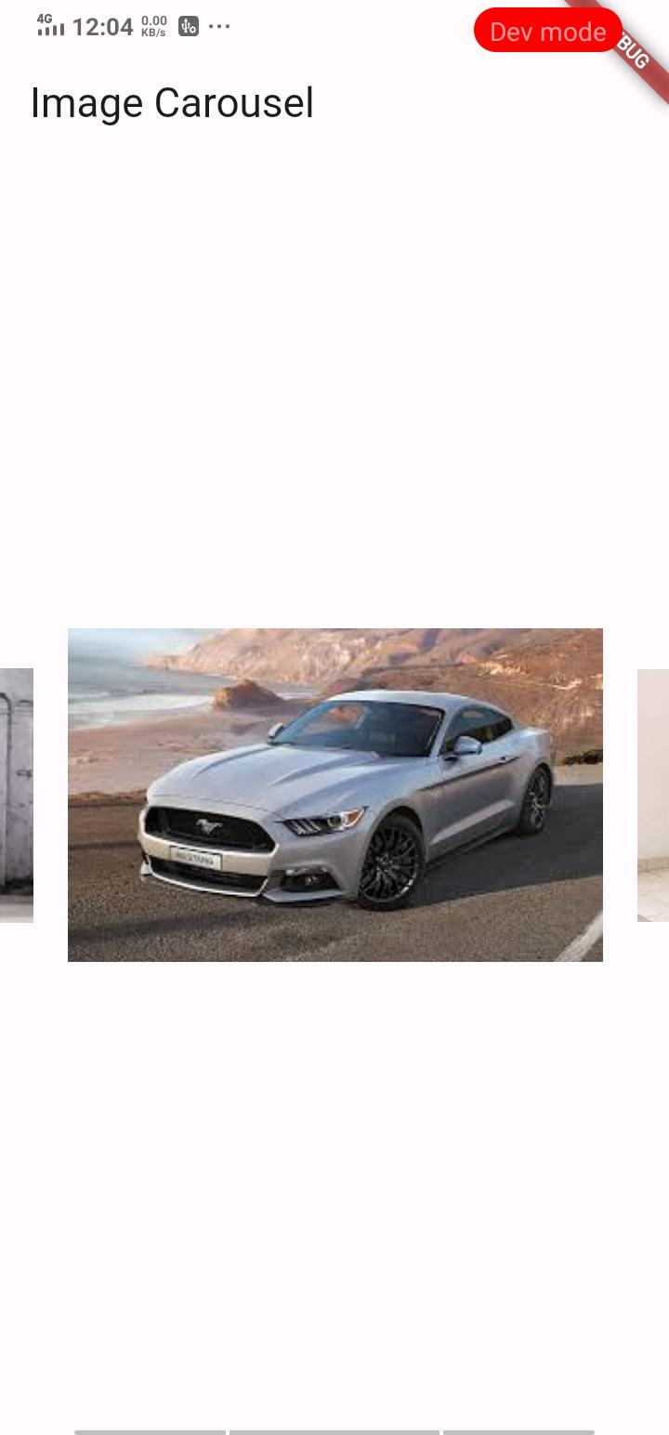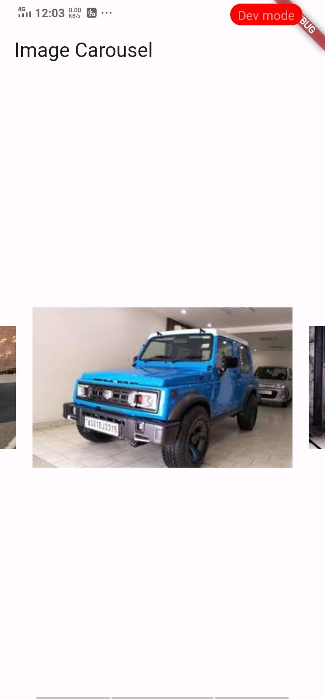

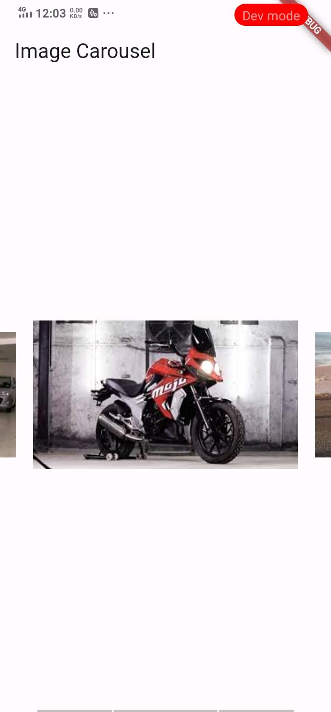

# **How to submit your Exercise**

Push your project back to the same git branch using command:

<command name>

# **Happy Coding!**